1. Open the event log ('Receipt phase of an environmental permit application process (_WABO_) CoSeLoG project.fbt') in Disco and switch to the 'Statistics' view.

Without switching to other views, use the statistics view to answer the following three subquestions:

1. How many events are there on average per case?

My Approach: I imported the “recepitent phase of environmental permit…” file into disco and clicked on the statistics tab.

My observation: In the statistics screen, I have recognized the values such as number of events and cases, from these I can find average number of events per case.

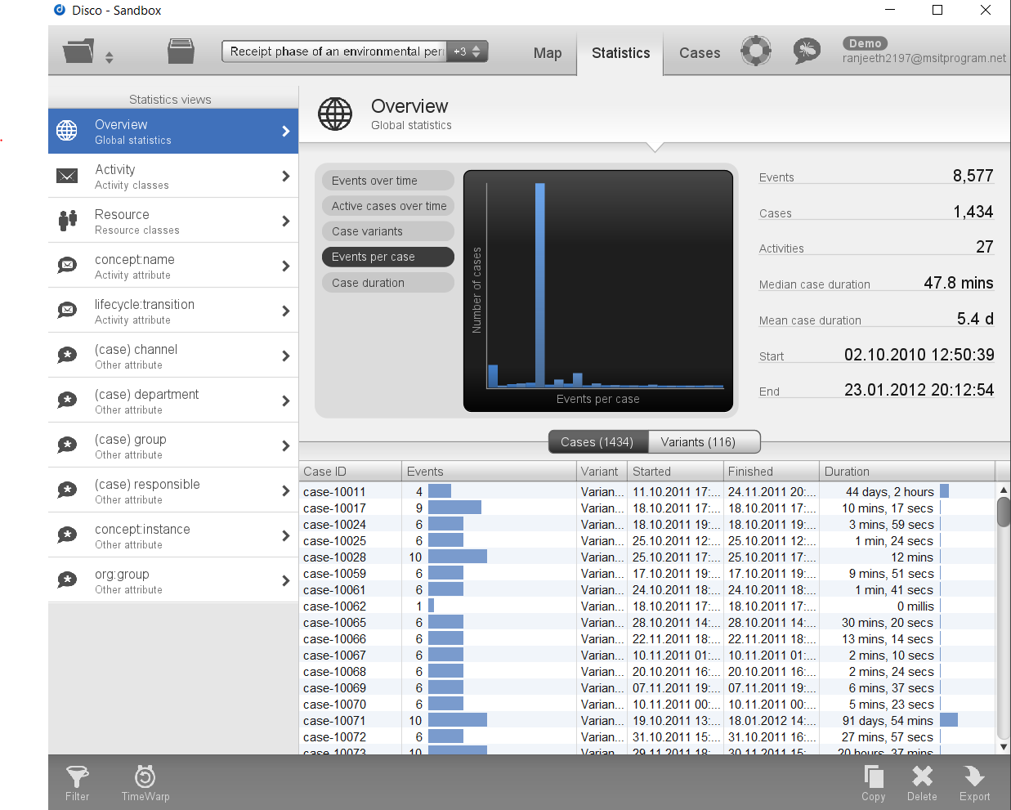

My Analysis: From the above observations,

Number of Events = 8577

Number of Cases = 1434

Number of events per case = 8577/1434 = 5.98 =~ 6

Therefore, I conclude that there are 5.98(Approximately 6) events per case.

1. Can you indicate whether each case seems to be unique or whether many cases follow the same activity sequence?

My Approach: I have viewed both cases and statistics pages but there is no specific number of unique cases.

My Observation: I have observed that the cases are unique but some of the cases are divided and belongs to a variant type, so these variants are unique.

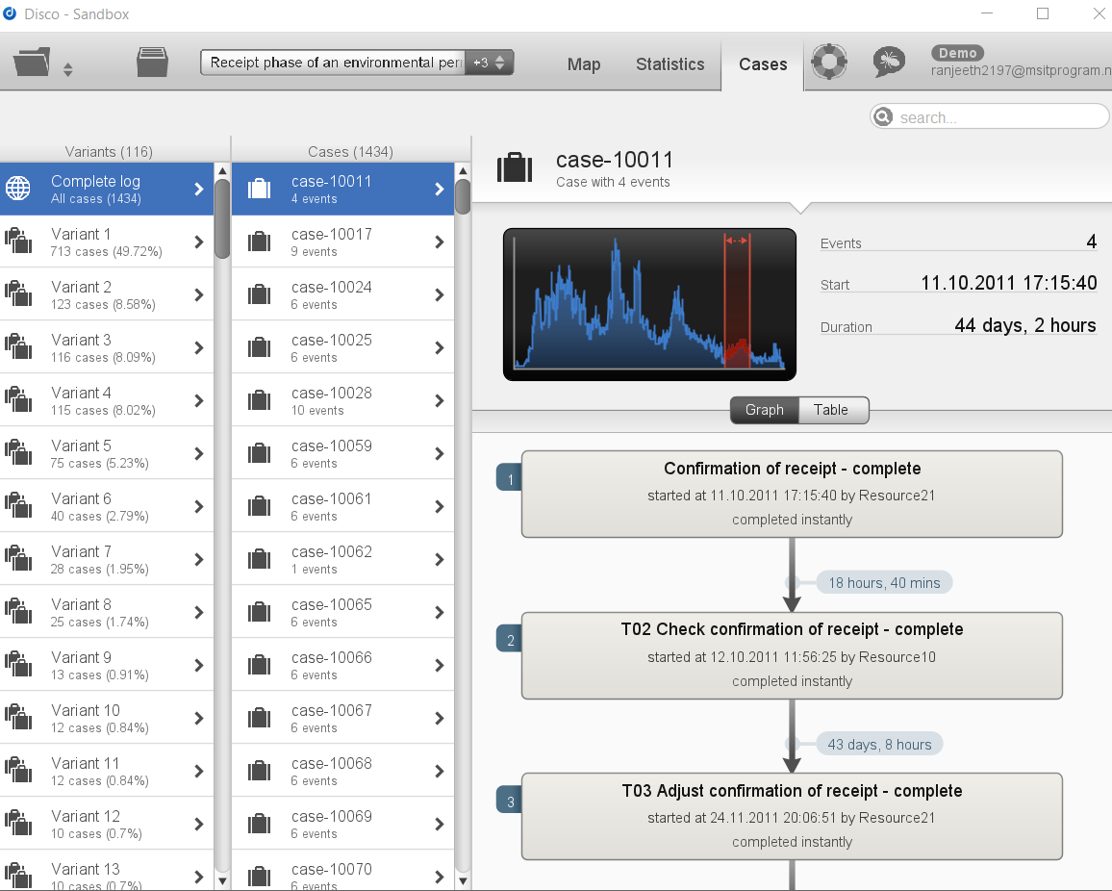

My Analysis: From my observation , from above picture I can say that there are 116 types of variants where consists of 1434 events.

1. What is the main observation that can be made from the 'Events over time' graph?

My Approach: I opened the Events over time page. I hovered over the graph plot given, to find out values plotted in graph.

My Observation: I observed that on most of the days, the number of events recorded is zero. Also some same number of events are recorded on each day excluding some outliers.

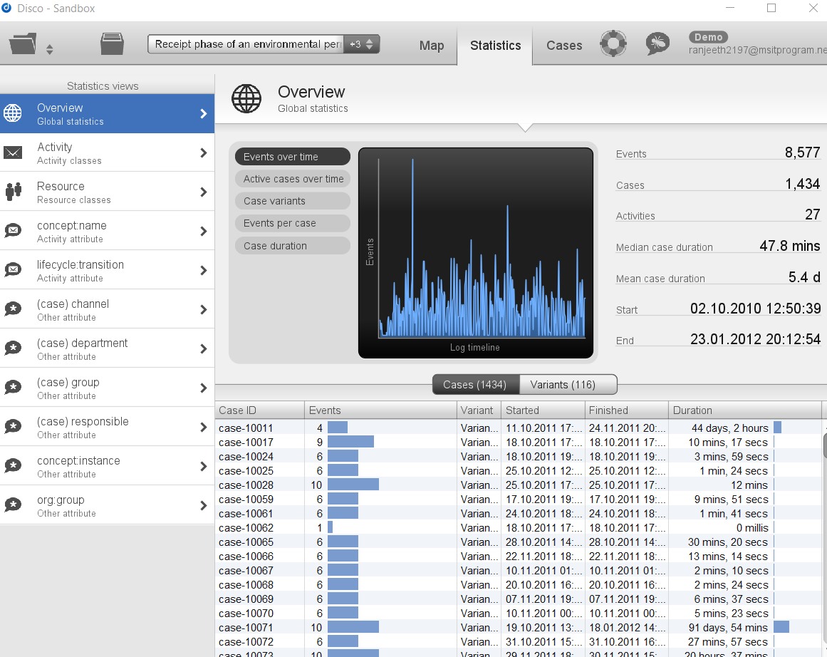

**My Analysis**: So, I conclude that, from the events over time graph the events and their occurrence over the time are given in the graph.

**2. Using the map view, change the activity and path detail settings in order to create a comprehensible process map (e.g. a process map that could be printed on one A4 or letter paper or shown on a single computer screen while still being readable in full).**

1. Discuss this process map, what is the main process?

My Approach: Click on map which will display the process map diagram. It will display the map.

My observation: My observation from this below process map diagram is that T02 check confirmation of receipt is the main starting stage of the process.

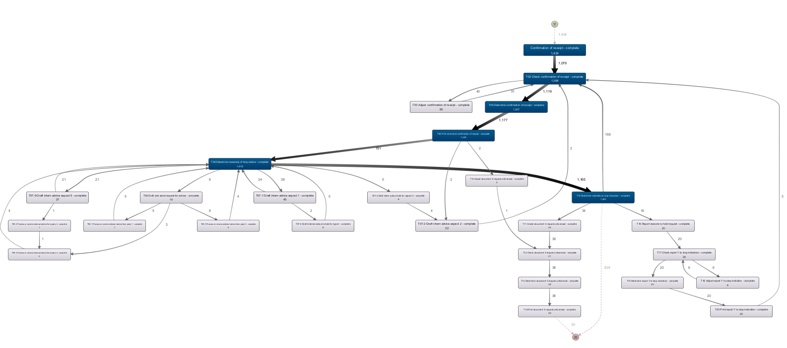

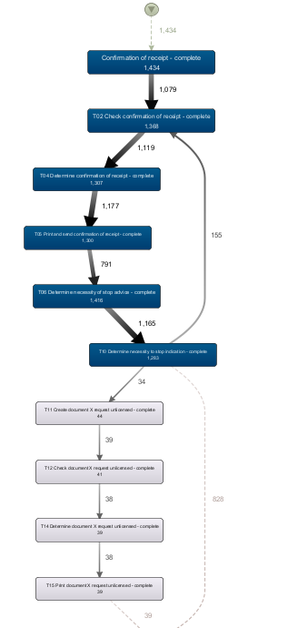

My Analysis/Conclusion: I conclude that the Check confirmation is main process, I conclude this hypothesis by adjusting **activity_slider = 13.9% and Path_slider = 0%,** which will represent the process map in a detailed and concise way.

1. Which activities and paths between activities are frequent?

My Approach: I click on map and adjusting the view of process map by setting **activities slider to 13.9% and paths slider = 0%** for better view.

My observation: My observation from the process map is that it contains 5 activities to be frequent than others.

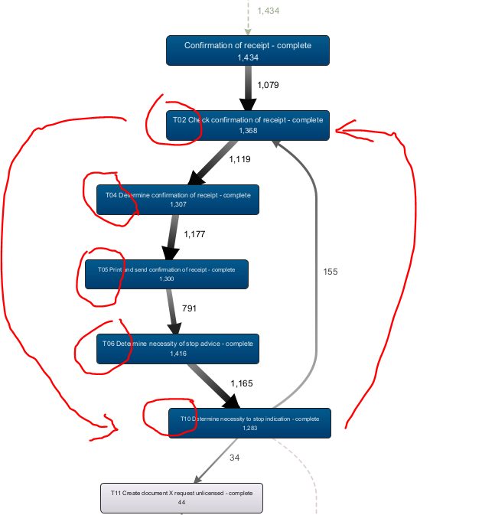

My Analysis/Conclusion: By above observation, I conclude that T02, T04,T05,T06 and T10 are the frequent activities as they are running on a loop which make them perform that activity again and again which makes them frequent.

**3.**

**While still in Disco, and while using the same process map (e.g. do not change the activity and path settings), switch to the performance projection.**

**Discuss where the process takes most time, e.g. where there are possibilities for improvement. Relate these times (of the bottlenecks) to the time spent in other parts of the process. In other words, discuss how severe the bottleneck is with respect to the time spent on other activities.**

**Also explicitly mention the performance metric chosen (e.g. total, mean, median, or max) and why you have chosen this setting.**

**My Approach:** FirstClick on the performance section that is in the right hand side botton of the screen, after pressing it I selected the total duration as my performance Metric.

**My observation:** I have observed that the total time duration between activities T05 and T06 is very huge i.e. 79.6 months.

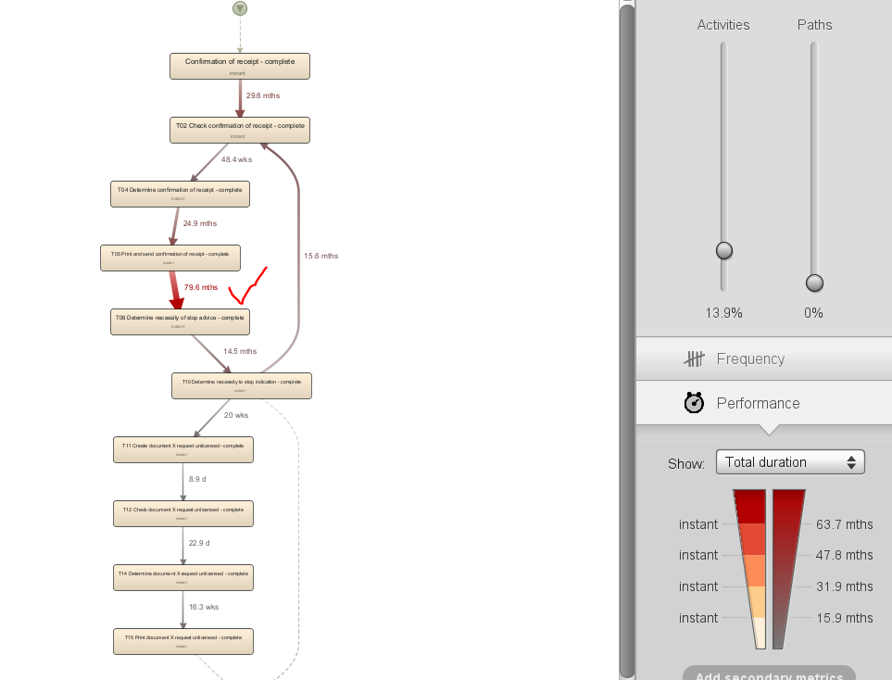

**My Analysis/Conclusion**: I conclude that I have chosen performance metric as total duration so that I can know the actual duration of every process activity. So, I found out a bottle neck at activity T05 and T06 which takes time of 79.6 months, which is very much time which affects the stalling of other processes.

4.Now load the original event log in ProM. Visualize the event log using the Dotted Chart or XDottedChart visualizer (by pressing the 'eye'-icon with the event log selected and switching to the Dotted Chart or XDottedChart visualizer).

Using the Dotted Chart, answer the following questions:

1. Is the arrival rate of new cases constant? If not, when are there fluctuations? If yes, how can we see this from the Dotted Chart?

My Approach: Imported the .xes file from dataset folder to the ProM, and by clicking on play button, it will allow us to select the type of plug-in. I selected Dotted chat visualizer and then clicked start. After clicking on ‘eye’ icon, we can see the dotted chart.

My observation: From my observation, it is clear that the arrival rat of new cases is constant.

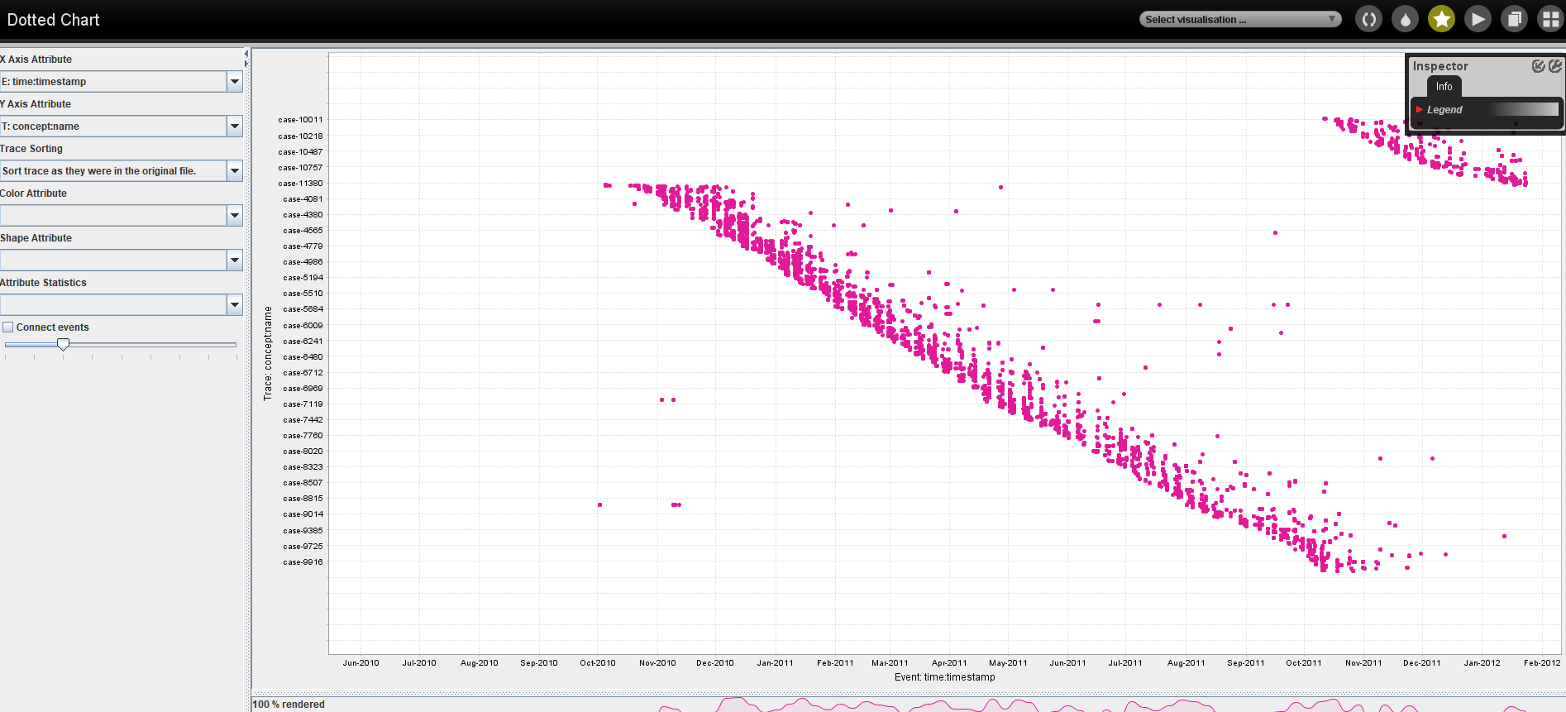

My Analysis/Conclusion: From the above observation, I can conclude that the arrival of new cases are constant. As we can see that new cases as the plot goes from September to again round the year but the dots are in a straight line not fluctuating anywhere.

1. Can you observe a change in the global process?

From the above observations from the dotted chart, there is only one color for process displaying “pink”. As there is no color change I conclude that there is no change in the global process.

**5. You are now asked to discover a Petri net on the event log. However, the unfiltered event log results in an incomprehensible Petri net. Therefore, you are allowed to run the 'Filter log using simple heuristics' plug-in *once* on the original event log to discover a Petri net on the filtered event log.**

1. Clearly indicate which settings you have used for the 'Filter log using simple heuristics' plug-in.

* Click on play button and then select the event log file and click select.
* Now, enter the plug-in as “Filter log using simple heuristics” in search bar.
* From the list of all plugins, select the appropriate search result and then click start.

1. Explicitly motivate the filtering settings chosen, why did you pick this percentage or selection of activities?

I pick this activities as it contains the main process and the reminaing important acitvites that are clear for understanding.

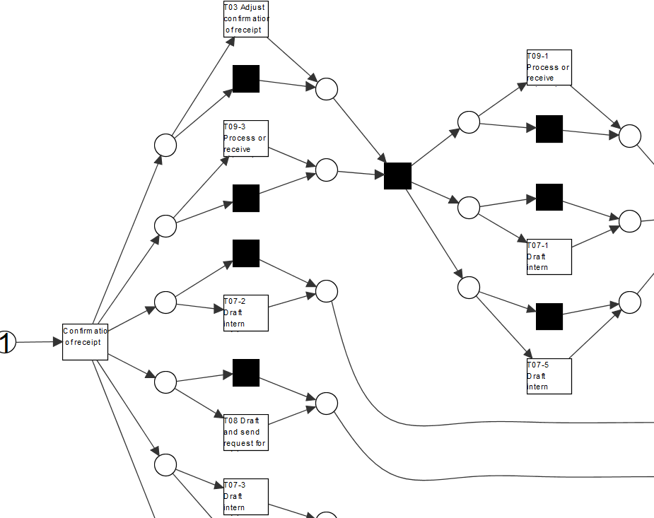

1. Discuss and argue which plug-in (or chain of plug-ins) you have used to discover a Petri net, for instance by comparing two or more plug-in results and arguing why one of the Petri nets is better.

* First one I chosen is “Mine for a Petri net with Inductive Miner”.

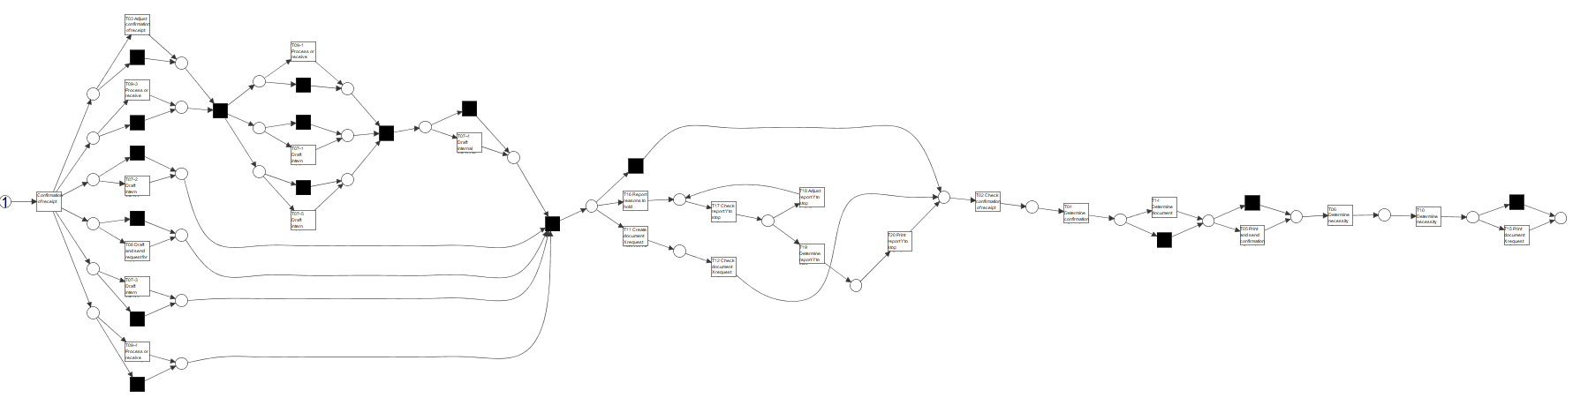

Second one is Mine for petrinet using Alpha miner.

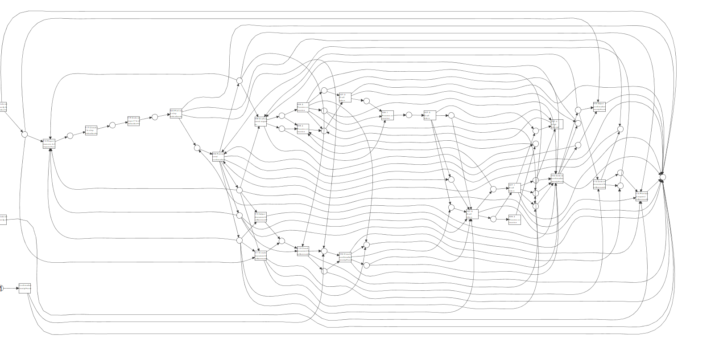

My Obervation: From the above two implementations, I conclude that the petri net using the Inductive miner is best as the activity flow is clear compared to alpha miner where the activity flow is not clear enough for easy understanding.

1. Explain the (best) Petri net: what is the main process and what are notable parts of the Petri net?

My analysis: The bet petrinet is using the inductive miner.

The main process in this is “Confirmation of receipt”. And “check confirmation of receipt is the notable part of petri net as it is the another main process at the end stage of the net.

**6.The organization has a process model that describes the 'should be' process (i.e. a normative process model). Load the file 'normativeModel.pnml' into ProM and apply conformance checking on this process model, and on the full unfiltered original event log.**

1. Include a screenshot of the part of the normative process model, with the conformance information projected onto it, that shows where most of the deviations occur.

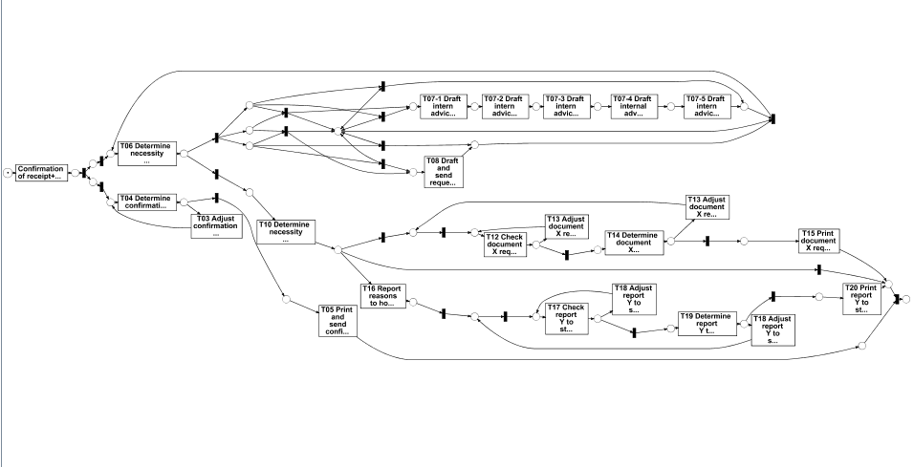

1. What is the replay fitness (the 'trace fitness' statistic) of the event log on the normative process model?

I am unable to use trace fitness feature.

1. Select the transition 'T06 Determine necessity of stop advice+complete' (on the top left of the model) and discuss its element statistics: how many times is the transition executed correctly and how many times incorrectly?

* Not all the users are executing the activities from start of event.
* Only some are executing most of activities.

1. Using the element statistics of transition 'T06 Determine necessity of stop advice+complete', what can you say about the (in)correct execution of this activity?

It is the correct execution of the stop+advice+complete activity.

7.

**The final analysis you have to perform on the original event log is a resource analysis, e.g. looking at the user behaviour in the event log.**

1. Use the plug-in 'Mine for a Subcontracting Social Network'. Note that subcontracting means that if individual *j* frequently executed an activity in-between two activities executed by individual *i*, then individual *i* subcontracted work to individual *j*. Answer the following question using this view: Can two or more groups of users be distinguished? Explicitly discuss the settings you have used in the resulting visualization.

**MyApproach**: I imported the xlog file and clicked on use this resource in resource page. And then I searched for the plug-in ‘Mine for subcontracting social network’. After starting that activity, an output visualization appeared.

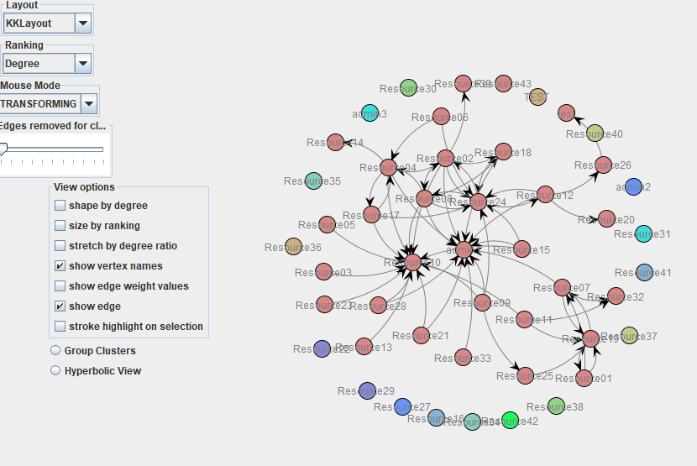

1. Again use one of the two Dotted Chart plug-ins. For the XDottedChart change the component type to 'org:resource'. If you use the Dotted Chart visualizer change the 'Y Axis Attribute' to 'C: Resource classifier' and the color attribute to 'C: Activity Classifier'. Answer the following two questions using this view:

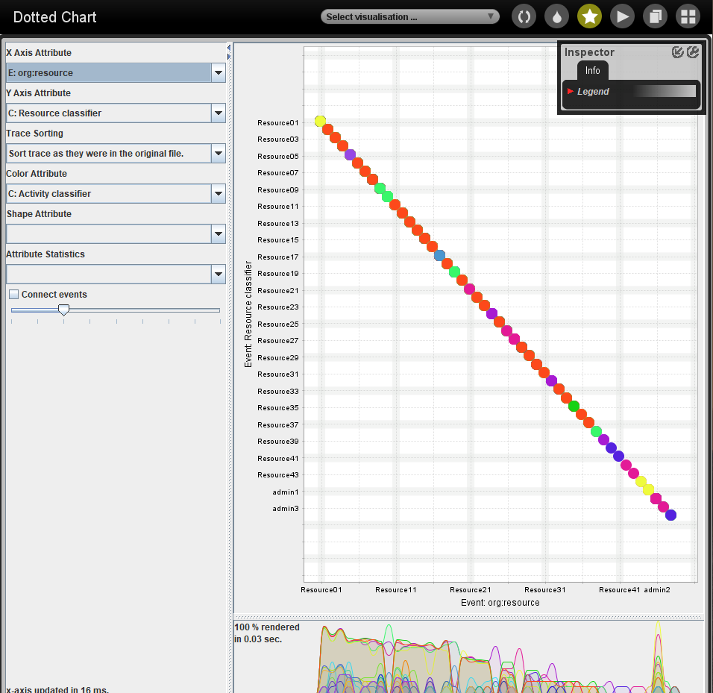

1. Are all users executing activities from the start of the event log, or are some users joining later?

Not all the users are starting from the start of event log. As we can for every new resource one place is shifting right side.

1. Are users mainly executing particular activities or are most users executing most of the activities?

Users mainly executing particular activities.